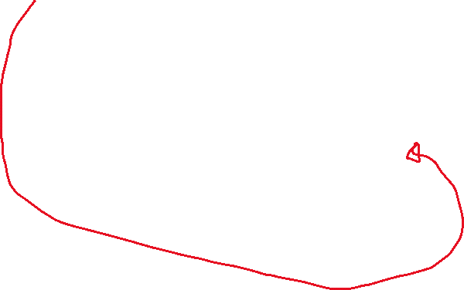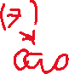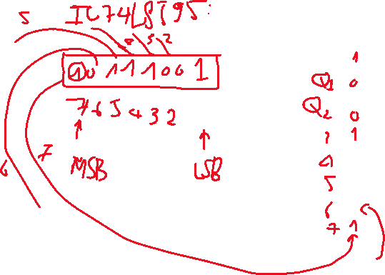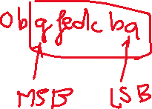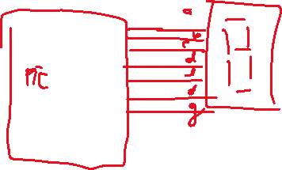

<https://youtu.be/x0jjlbhxlQU>

<https://youtu.be/O4zl1qqaFVk>

Giáo trình vi điều khiển, sách web

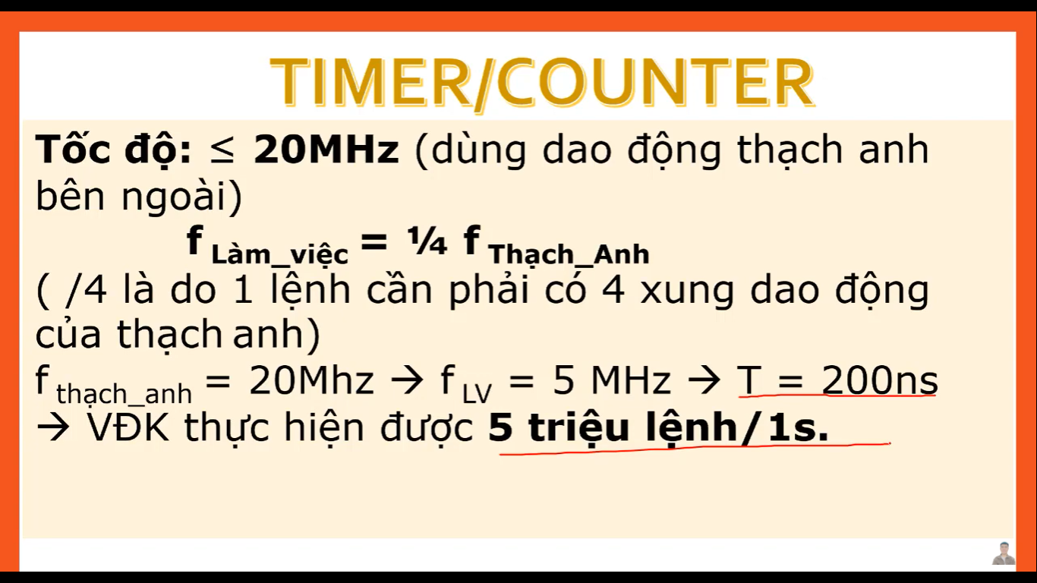



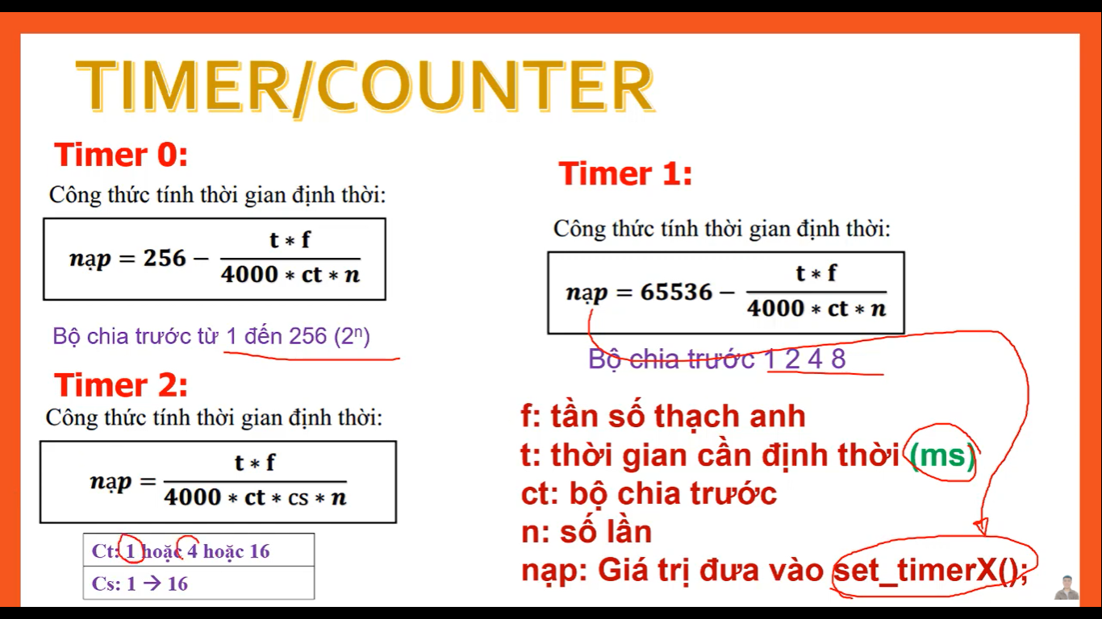



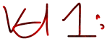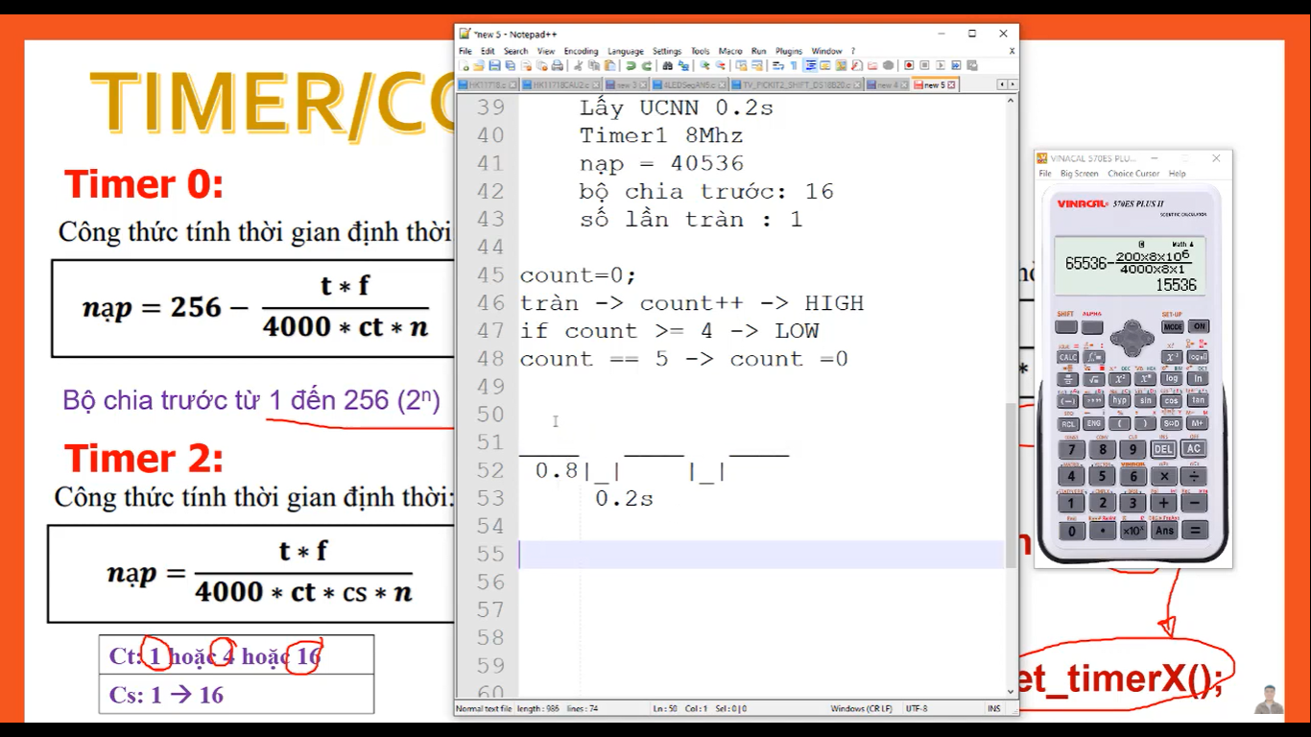



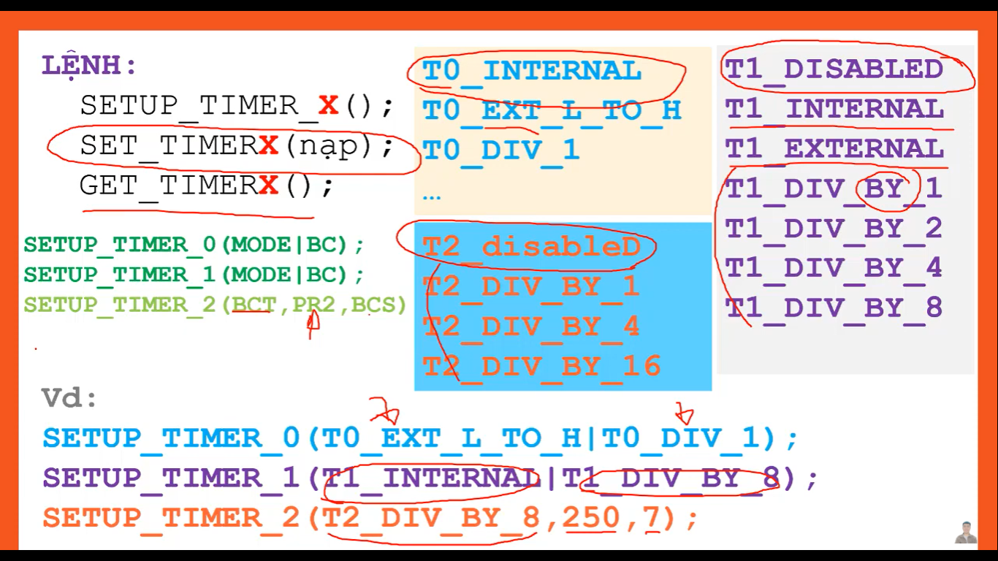

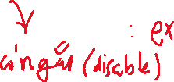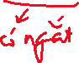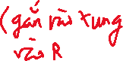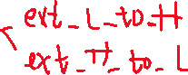

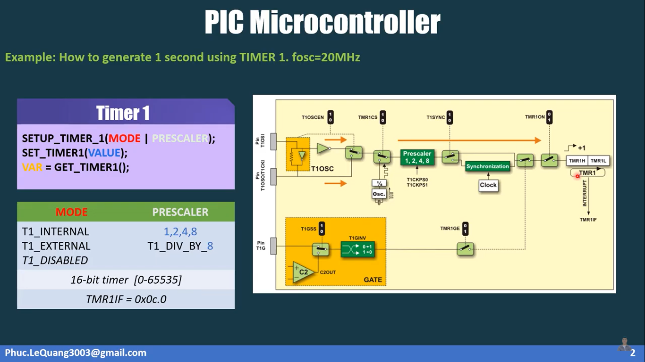

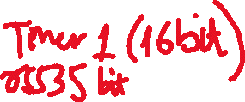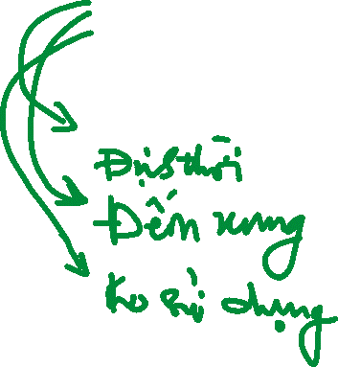

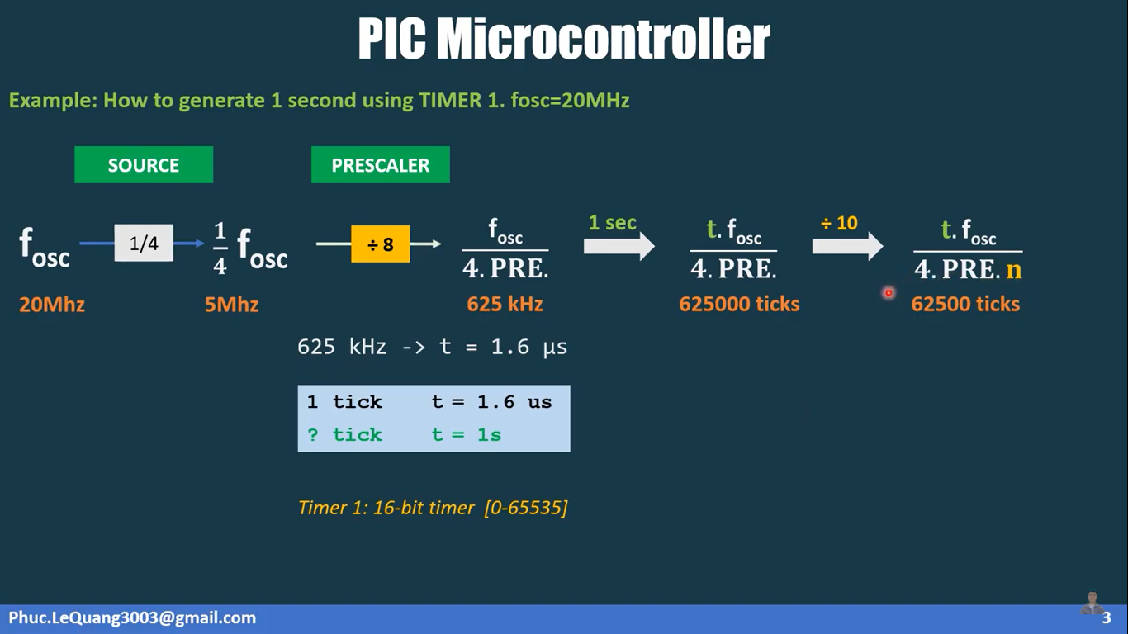

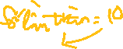

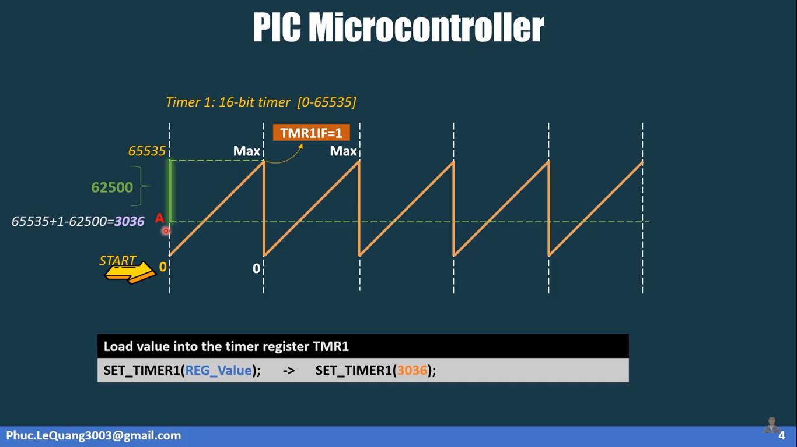



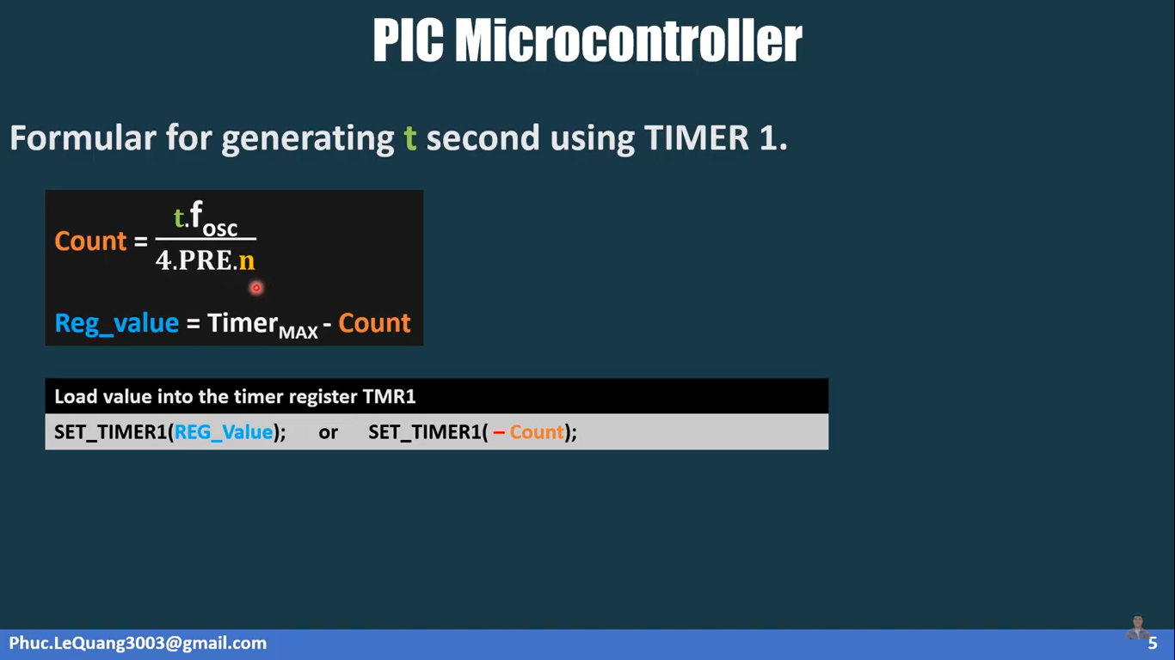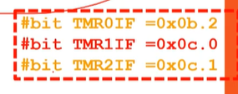



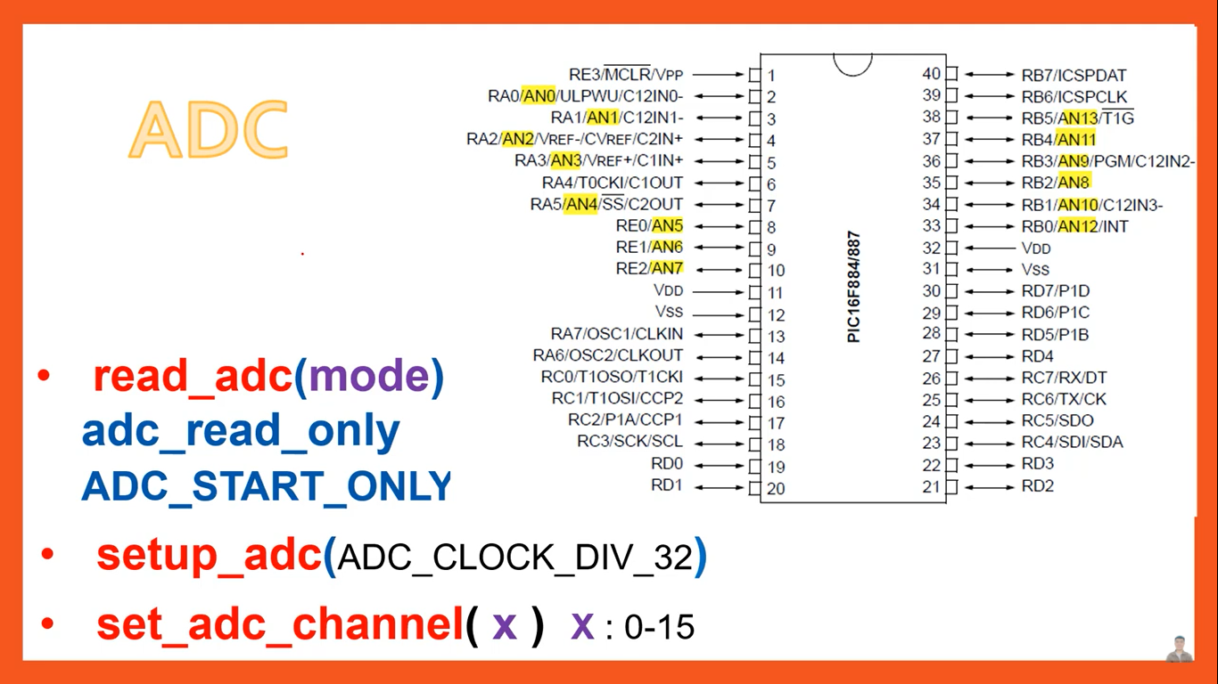



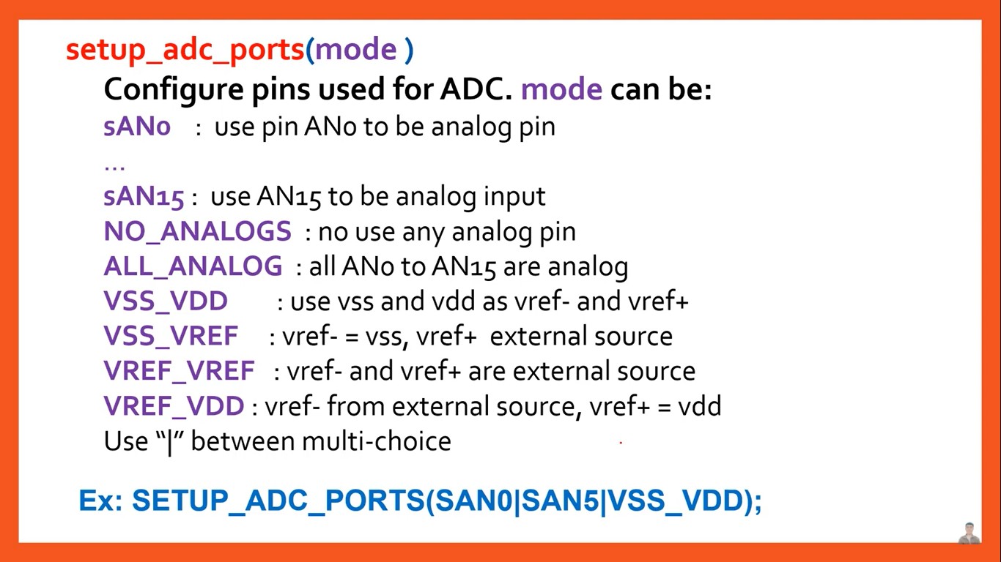



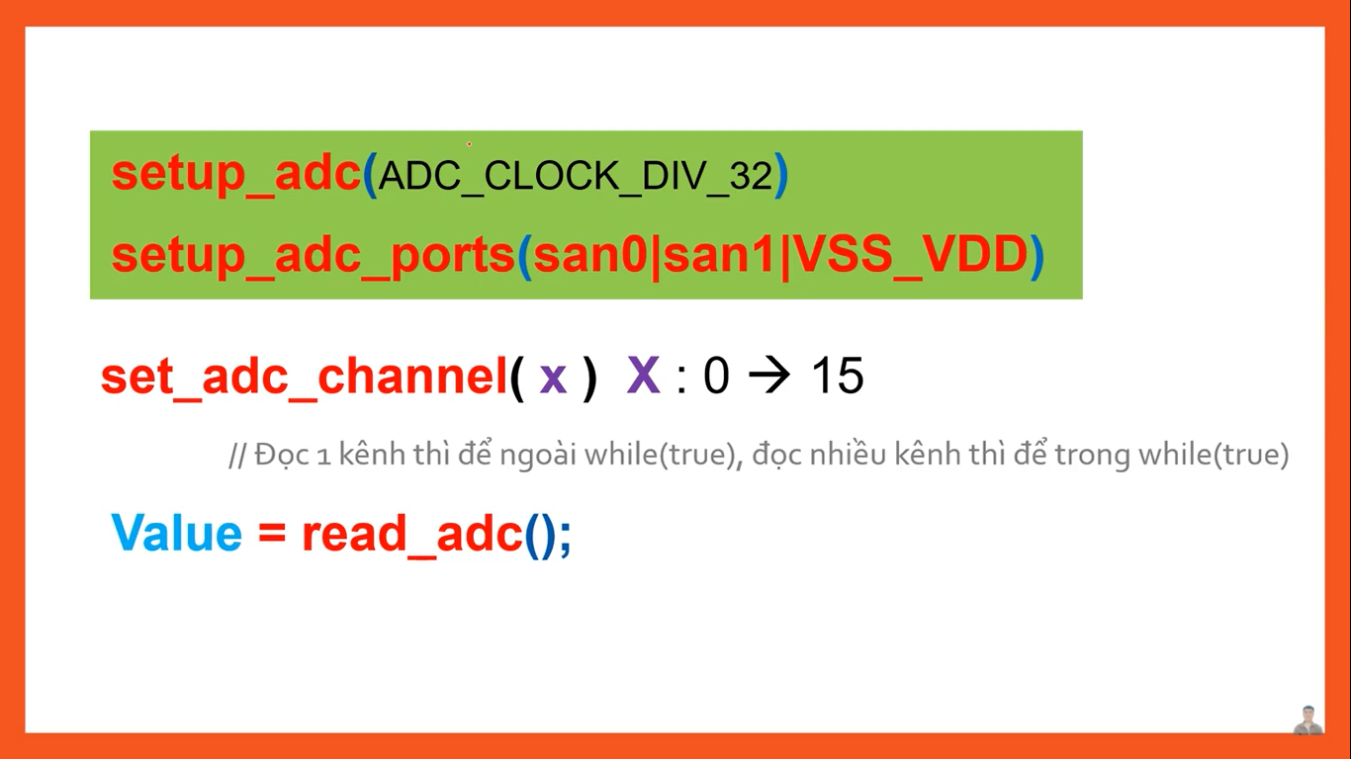



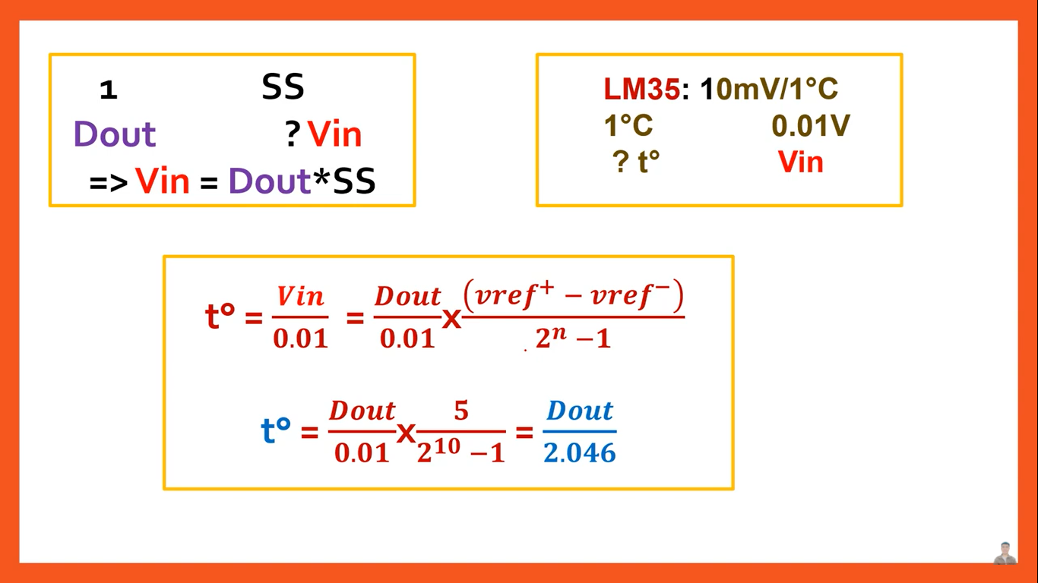



<https://tienich123.wordpress.com/2017/10/21/bai-7-mplab-xc8-lap-trinh-doc-adc/>

đọc thêm datasheet + Guide_MPLAB trong file TaiLieu (ổ C)



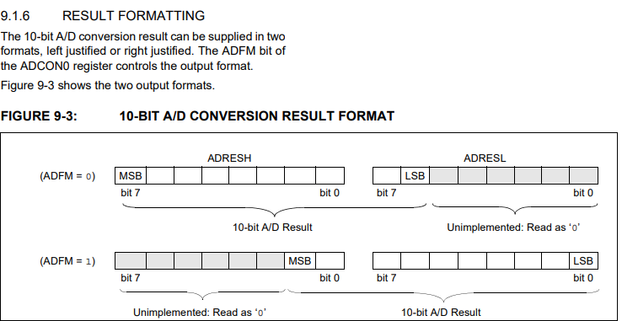

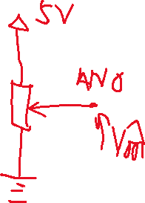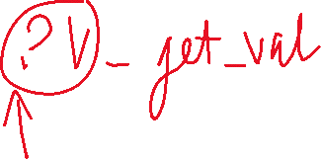

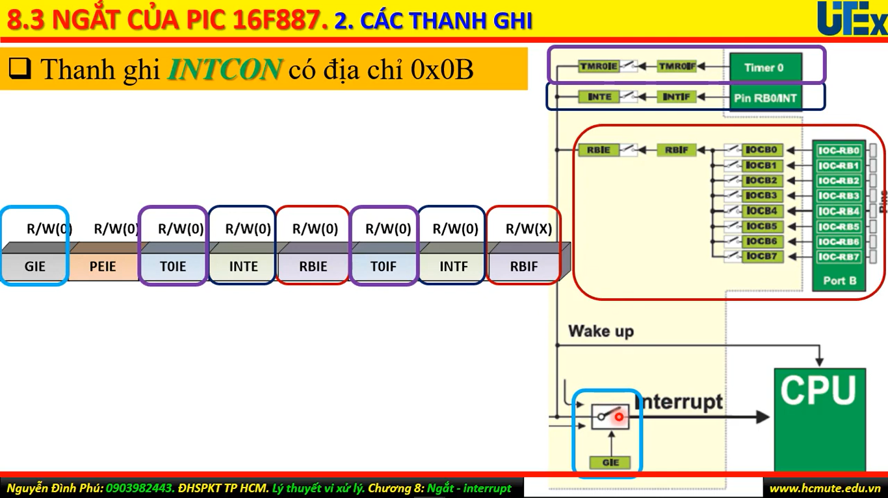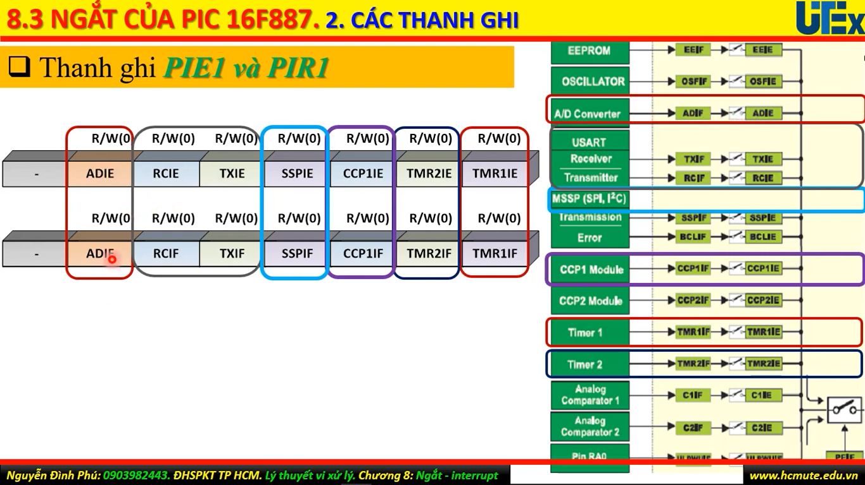

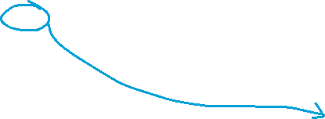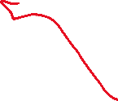

Link lý thuyết: <https://deviot.vn/tutorials/pic.22296474/ngat-ngoai.85253280>



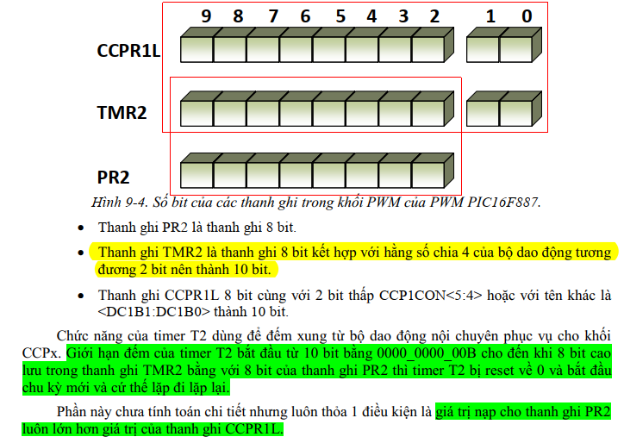

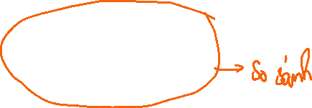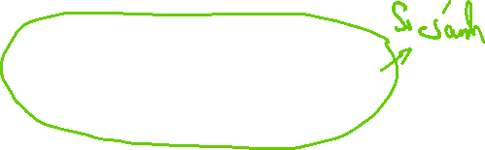

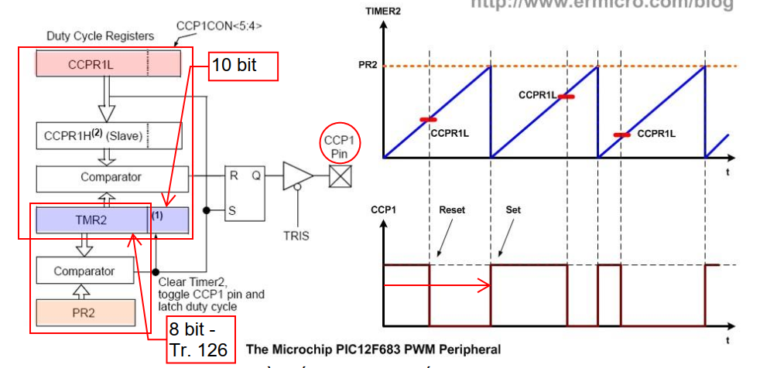



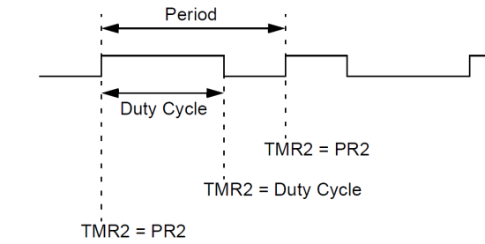

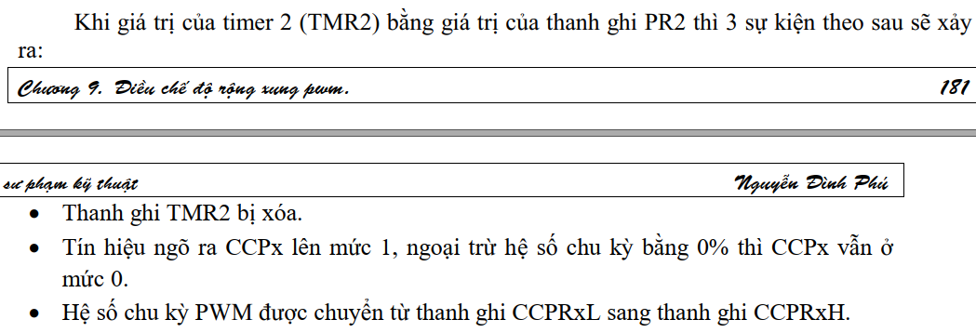



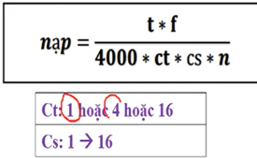

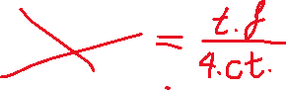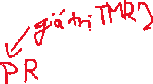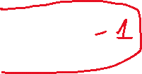



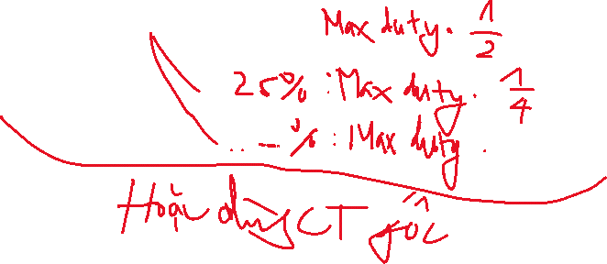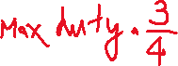

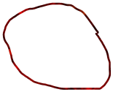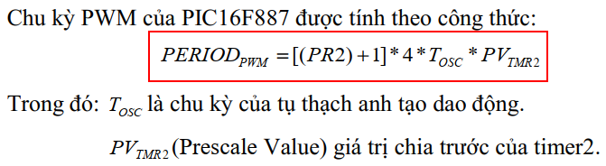

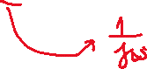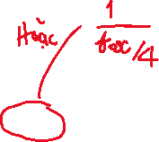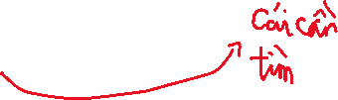

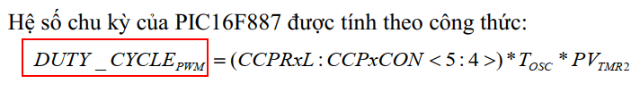

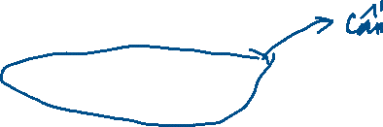

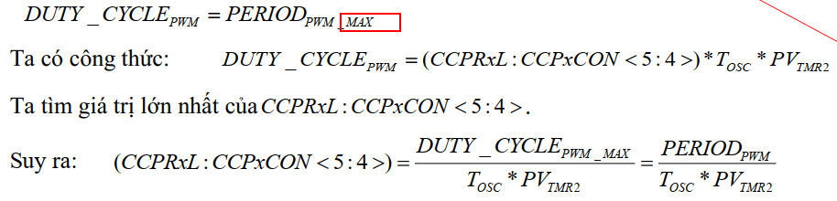



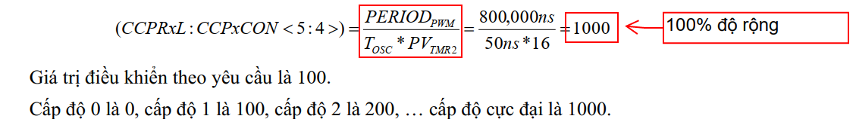



*DEBUG*

**There are Unresolve includes inside xc.h header,**

* *Project properties >> XC8 Global Optional >> XC8 Linker >> Link in C library >> C*
* *Hoặc là xóa luôn #include đó*

Để cho UART chạy thì: Phải cùng Baudrate bằng cách chỉnh set hardware or set software



#define _XTAL_FREQ 20000000

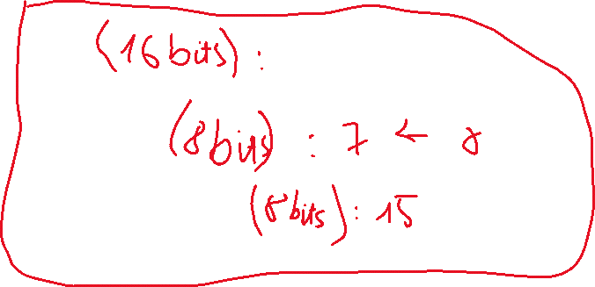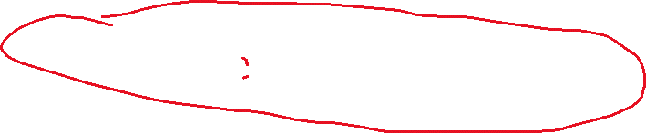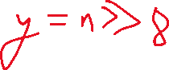

#define TMR2PRESCALE 4

#include *// BEGIN CONFIG*

#pragma config FOSC = HS *// Oscillator Selection bits (HS oscillator)*

#pragma config WDTE = OFF *// Watchdog Timer Enable bit (WDT enabled)*

#pragma config PWRTE = OFF *// Power-up Timer Enable bit (PWRT disabled)*

#pragma config BOREN = ON *// Brown-out Reset Enable bit (BOR enabled)*

#pragma config LVP = OFF *// Low-Voltage (Single-Supply) In-Circuit Serial Programming Enable bit (RB3 is digital I/O, HV on MCLR must be used for programming)*

#pragma config CPD = OFF *// Data EEPROM Memory Code Protection bit (Data EEPROM code protection off)*

#pragma config WRT = OFF *// Flash Program Memory Write Enable bits (Write protection off; all program memory may be written to by EECON control)*

#pragma config CP = OFF *// Flash Program Memory Code Protection bit (Code protection off)*

*//END CONFIG*

long freq;

int PWM_Max_Duty()

{

return(_XTAL_FREQ/(freq*TMR2PRESCALE);

}

PWM1_Init(long fre)

{

PR2 = (_XTAL_FREQ/(fre*4*TMR2PRESCALE)) - 1;

freq = fre;

}

PWM2_Init(long fre)

{

PR2 = (_XTAL_FREQ/(fre*4*TMR2PRESCALE)) - 1;

freq = fre;

}

PWM1_Duty(unsigned int duty)

{

if(duty<1024)

{

duty = ((float)duty/1023)*PWM_Max_Duty();

CCP1X = duty & 2;

CCP1Y = duty & 1;

CCPR1L = duty>>2;

}

}

PWM2_Duty(unsigned int duty)

{

if(duty<1024)

{

duty = ((float)duty/1023)*PWM_Max_Duty();

CCP2X = duty & 2;

CCP2Y = duty & 1;

CCPR2L = duty>>2;

}

}

PWM1_Start()

{

CCP1M3 = 1;

CCP1M2 = 1;

#if TMR2PRESCALAR == 1

T2CKPS0 = 0;

T2CKPS1 = 0;

#elif TMR2PRESCALAR == 4

T2CKPS0 = 1;

T2CKPS1 = 0;

#elif TMR2PRESCALAR == 16

T2CKPS0 = 1;

T2CKPS1 = 1;

#endif

TMR2ON = 1;

TRISC2 = 0;

}

PWM1_Stop()

{

CCP1M3 = 0;

CCP1M2 = 0;

}

PWM2_Start()

{

CCP2M3 = 1;

CCP2M2 = 1;

#if TMR2PRESCALE == 1

T2CKPS0 = 0;

T2CKPS1 = 0;

#elif TMR2PRESCALE == 4

T2CKPS0 = 1;

T2CKPS1 = 0;

#elif TMR2PRESCALE == 16

T2CKPS0 = 1;

T2CKPS1 = 1;

#endif

TMR2ON = 1;

TRISC1 = 0;

}

PWM2_Stop()

{

CCP2M3 = 0;

CCP2M2 = 0;

}

void main()

{

unsigned int i=0,j=0;

PWM1_Init(5000);

PWM2_Init(5000);

TRISD = 0xFF;

TRISB = 0;

PWM1_Duty(0);

PWM2_Duty(0);

PWM1_Start();

PWM2_Start();

do

{

if(RD0 == 0 && i<1000)

i=i+10;

if(RD1 == 0 && i>0)

i=i-10;

if(RD2 == 0 && j<1000)

j=j+10;

if(RD3 == 0 && j>0)

j=j-10;

PWM1_Duty(i);

PWM2_Duty(j);

__delay_ms(50);

}while(1);

}